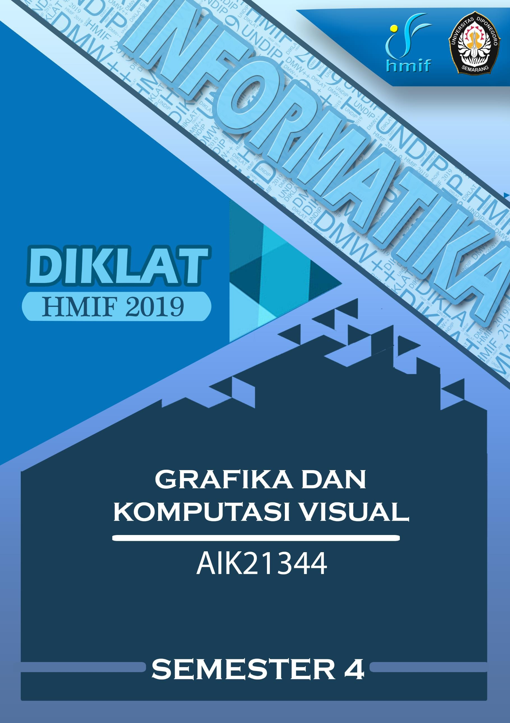

**DAFTAR ISI**

DAFTAR ISI 2

KUIS 2009/2010 3

UJIAN TENGAH SEMESTER 2012/2013 4

UJIAN AKHIR SEMESTER 2012/2013 5

UJIAN TENGAH SEMESTER 2013/2014 6

UJIAN AKHIR SEMESTER 2013/2014 7

UJIAN TENGAH SEMESTER 2014/2015 8

UJIAN AKHIR SEMESTER 2014/2015 9

UJIAN TENGAH SEMESTER 2015/2016 10

UJIAN AKHIR SEMESTER 2015/2016 11

UJIAN TENGAH SEMESTER 2016/2017 12

UJIAN AKHIR SEMESTER 2016/2017 13

UJIAN TENGAH SEMESTER 2017/2018............................................................................................ 14

UJIAN AKHIR SEMESTER 2017/2018................................................................................................. 15

**KUIS 2009/2010**

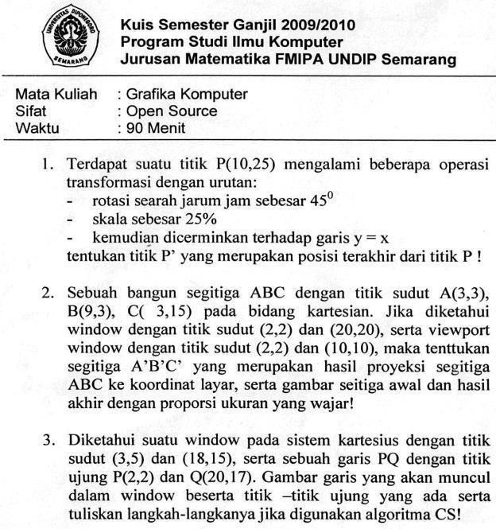

**UJIAN TENGAH SEMESTER 2012/2013**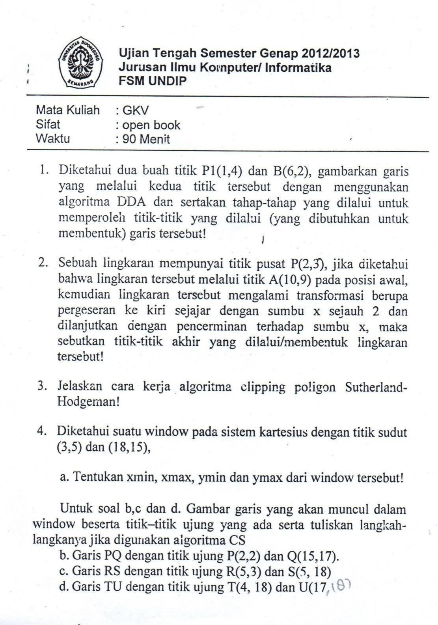

**UJIAN AKHIR SEMESTER 2012/201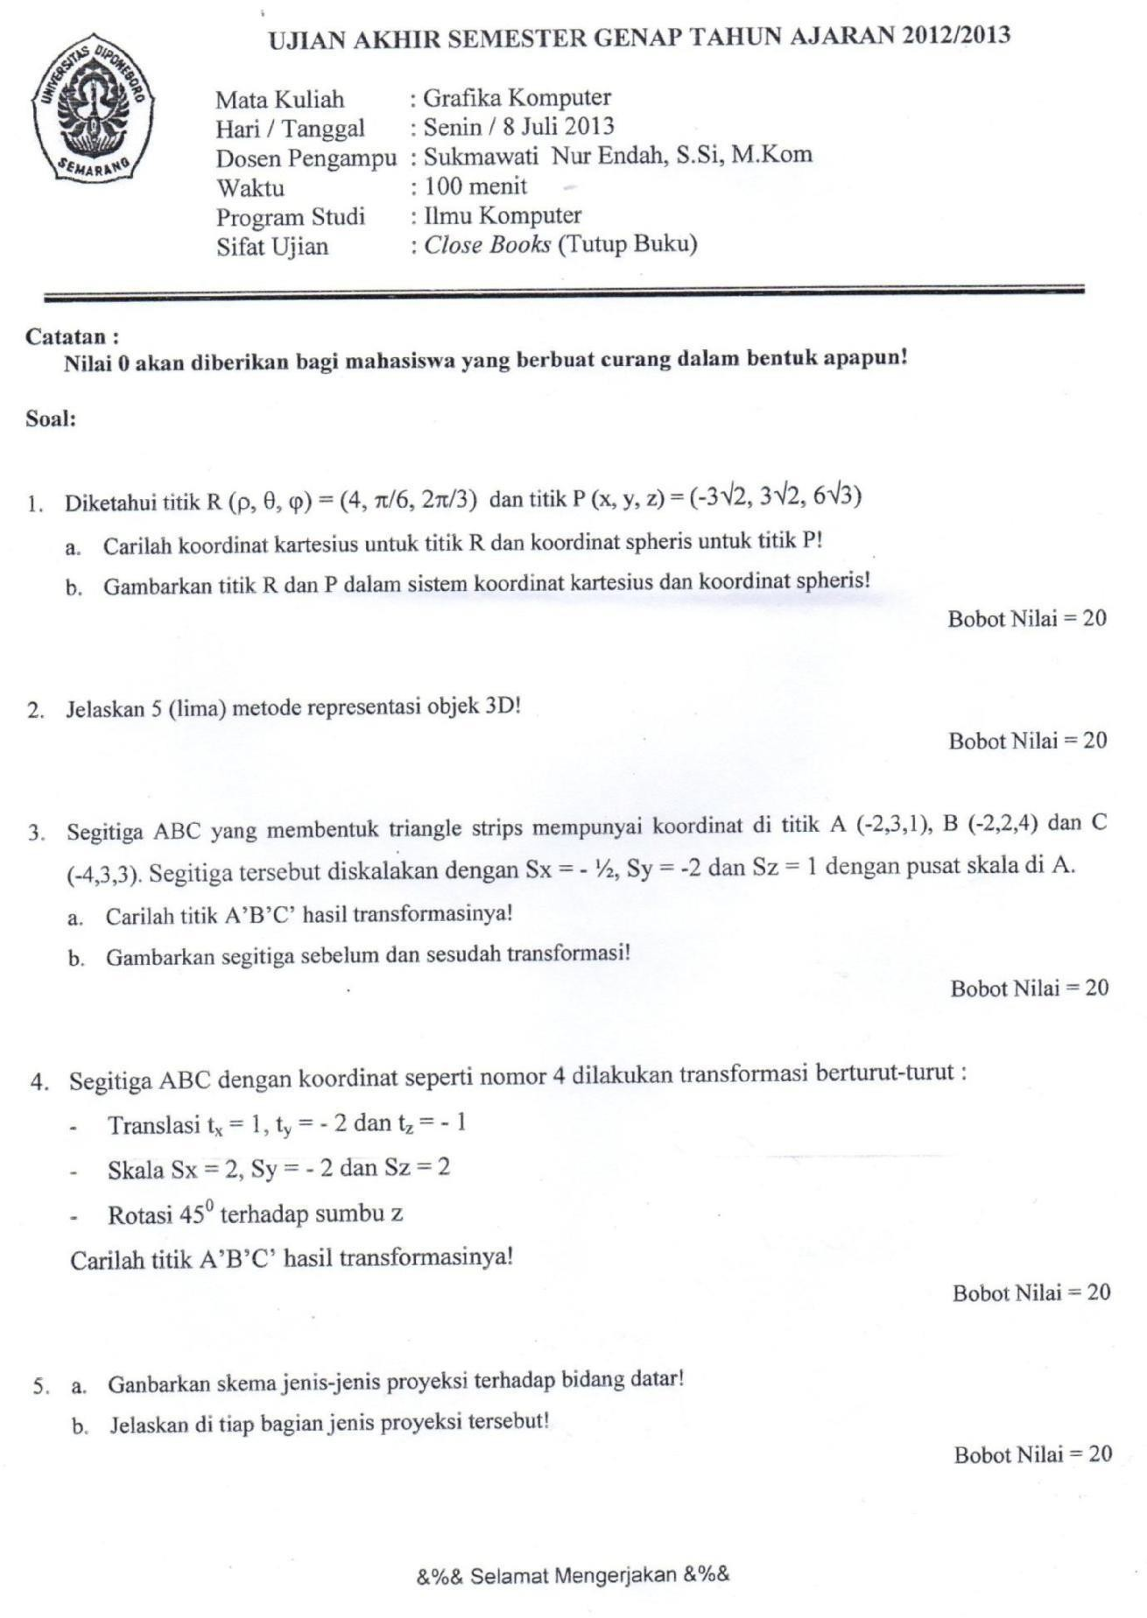3**

**UJIAN TENGAH SEMESTER 2013/201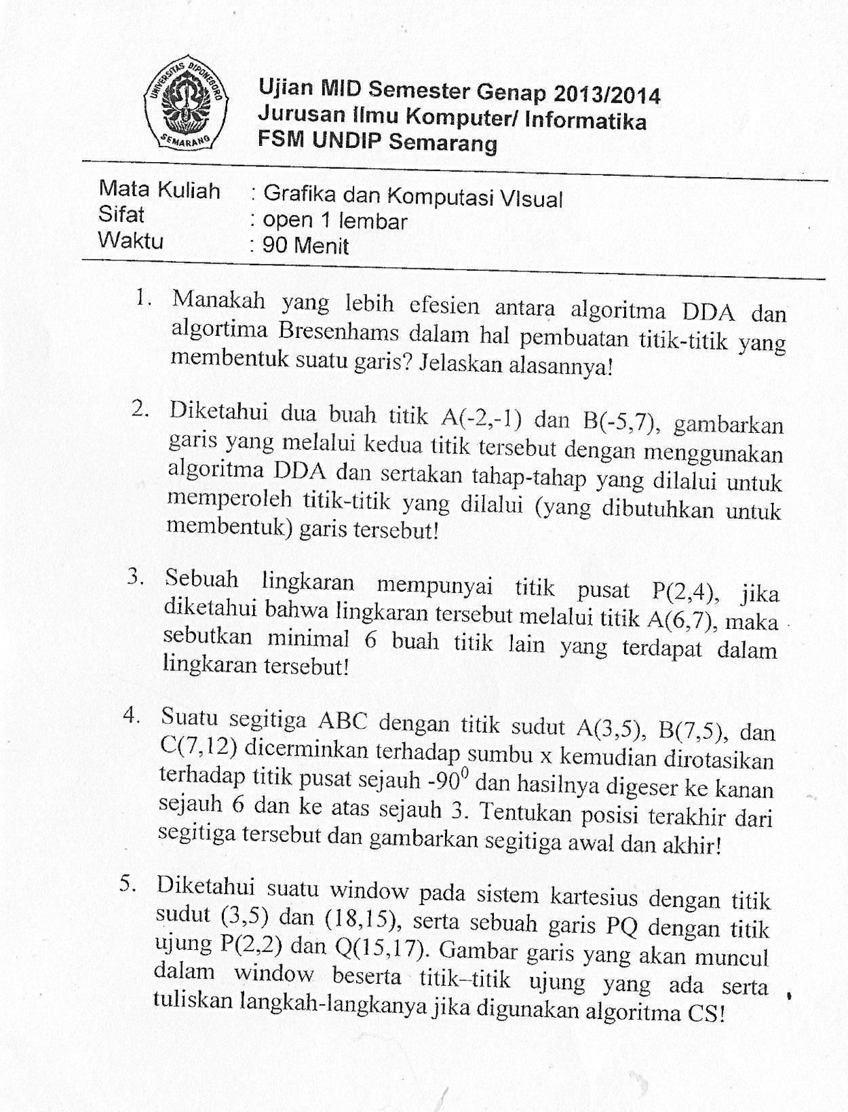4**

**UJIAN AKHIR SEMESTER 2013/2014**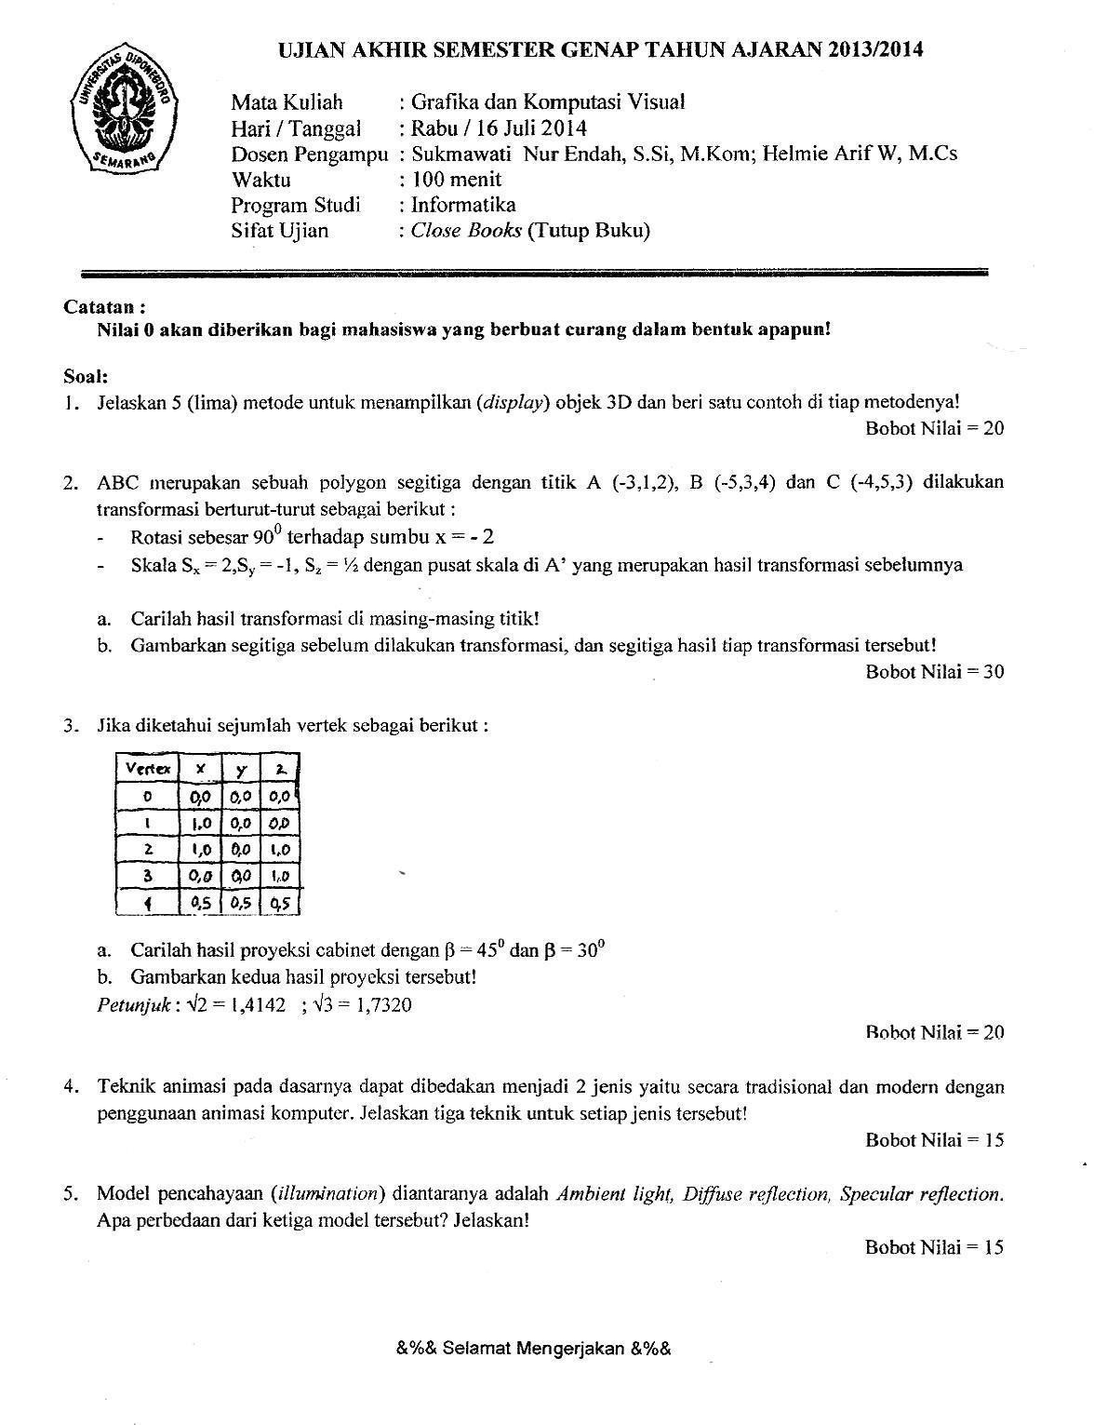

**UJIAN TENGAH SEMESTER 2014/2015**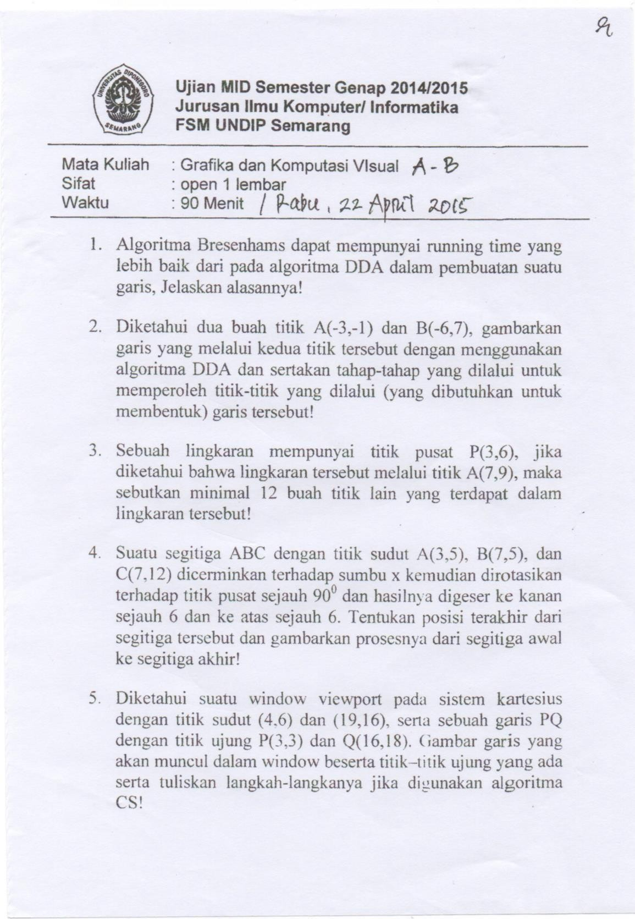

**UJIAN AKHIR SEMESTER 2014/2015**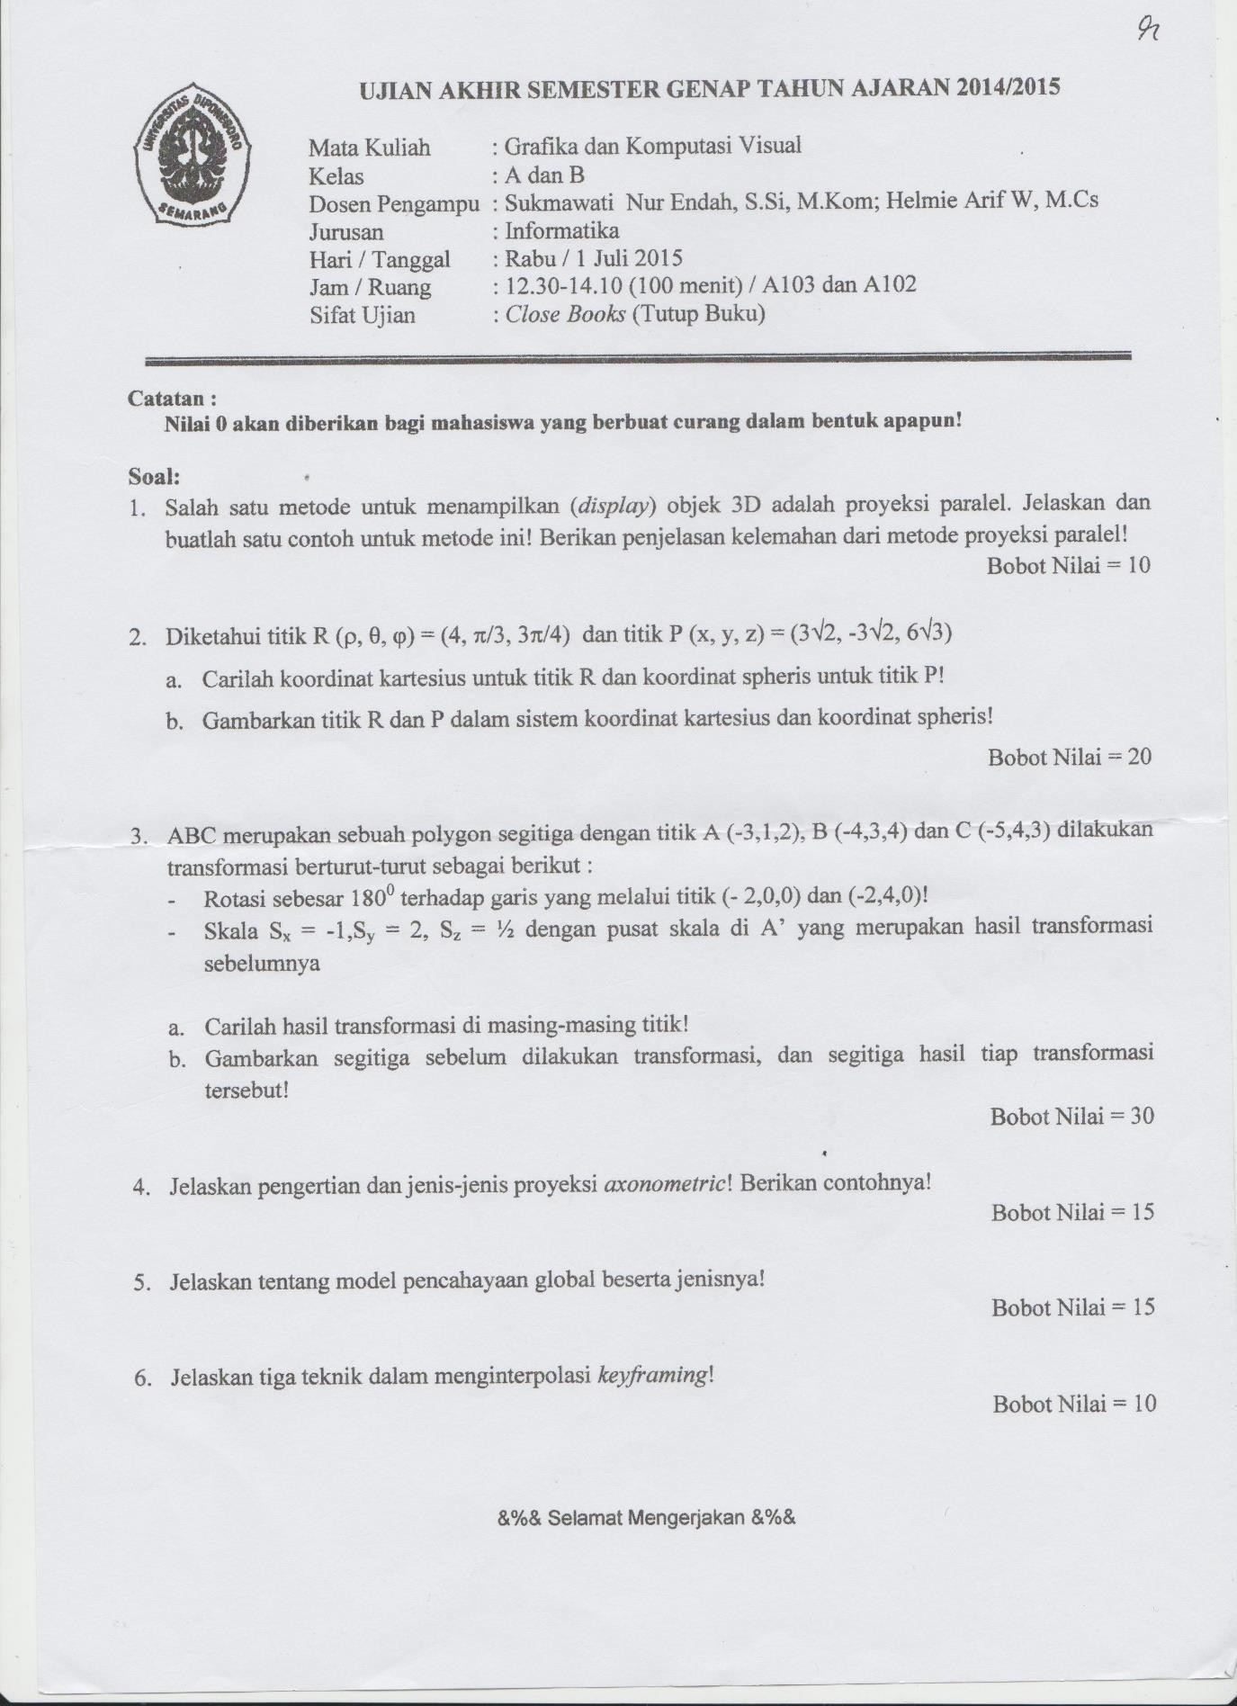

**UJIAN TENGAH SEMESTER 2015/2016**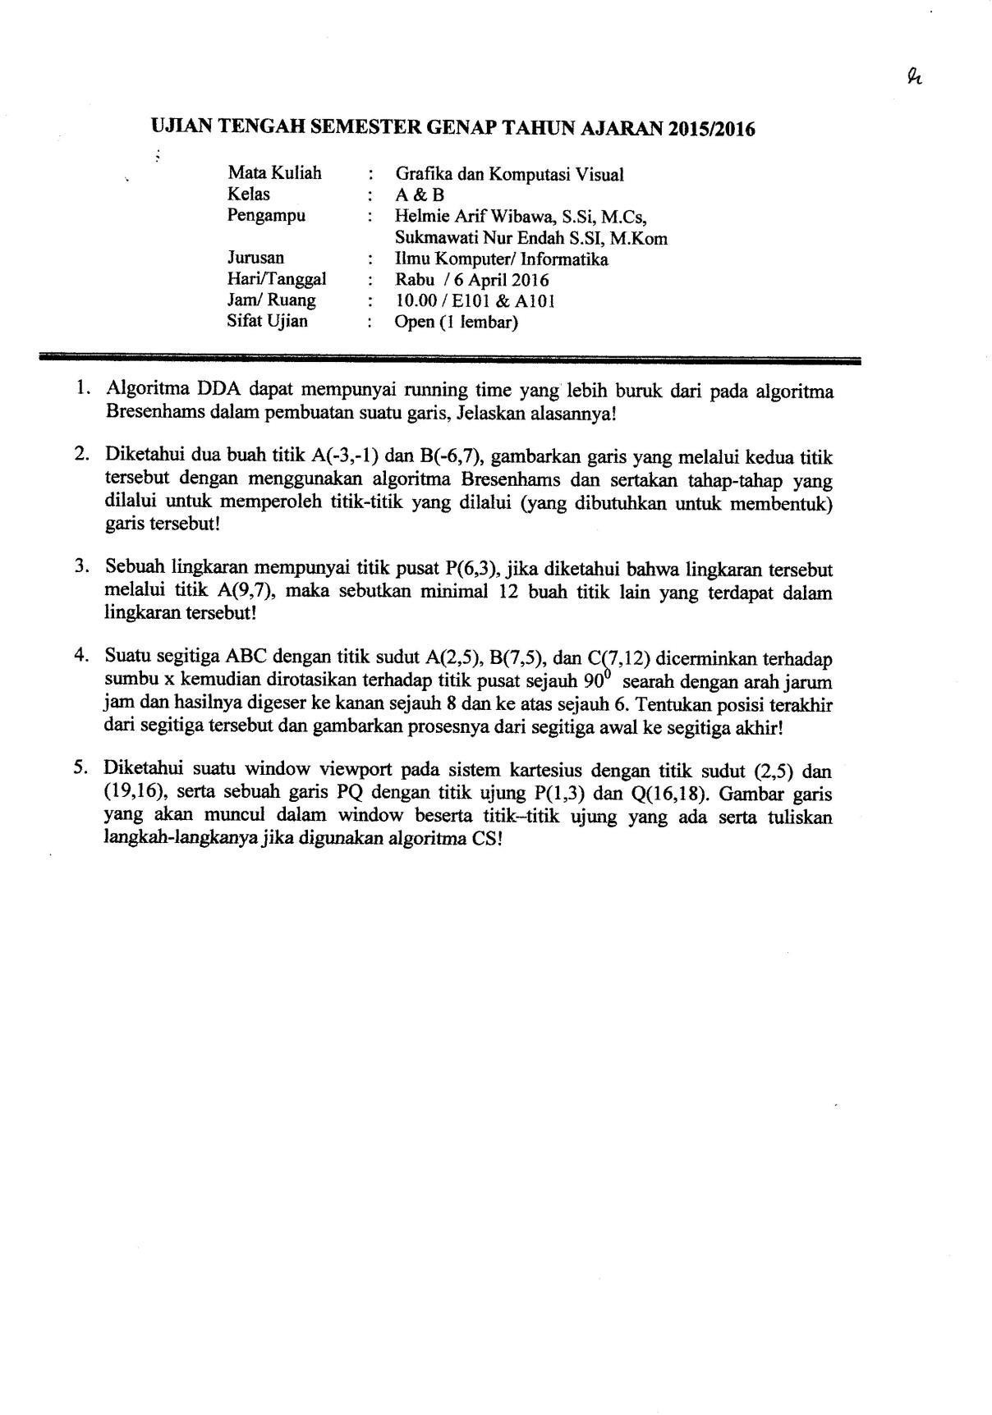

**UJIAN AKHIR SEMESTER 2015/2016**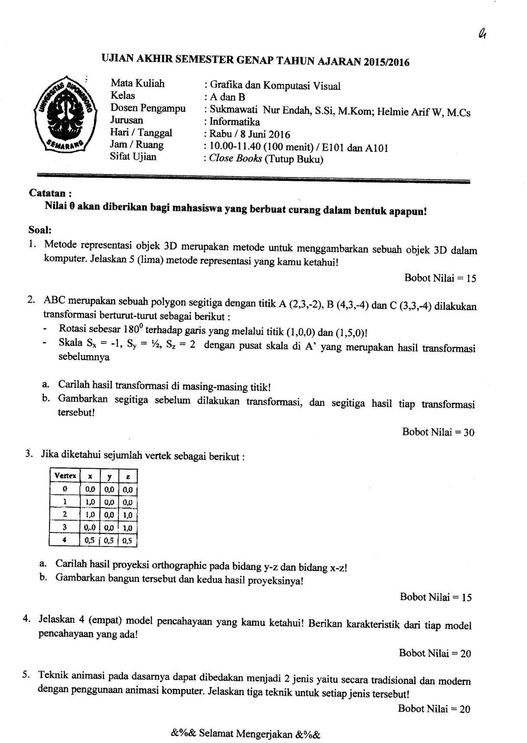

**UJIAN TENGAH SEMESTER 2016/2017**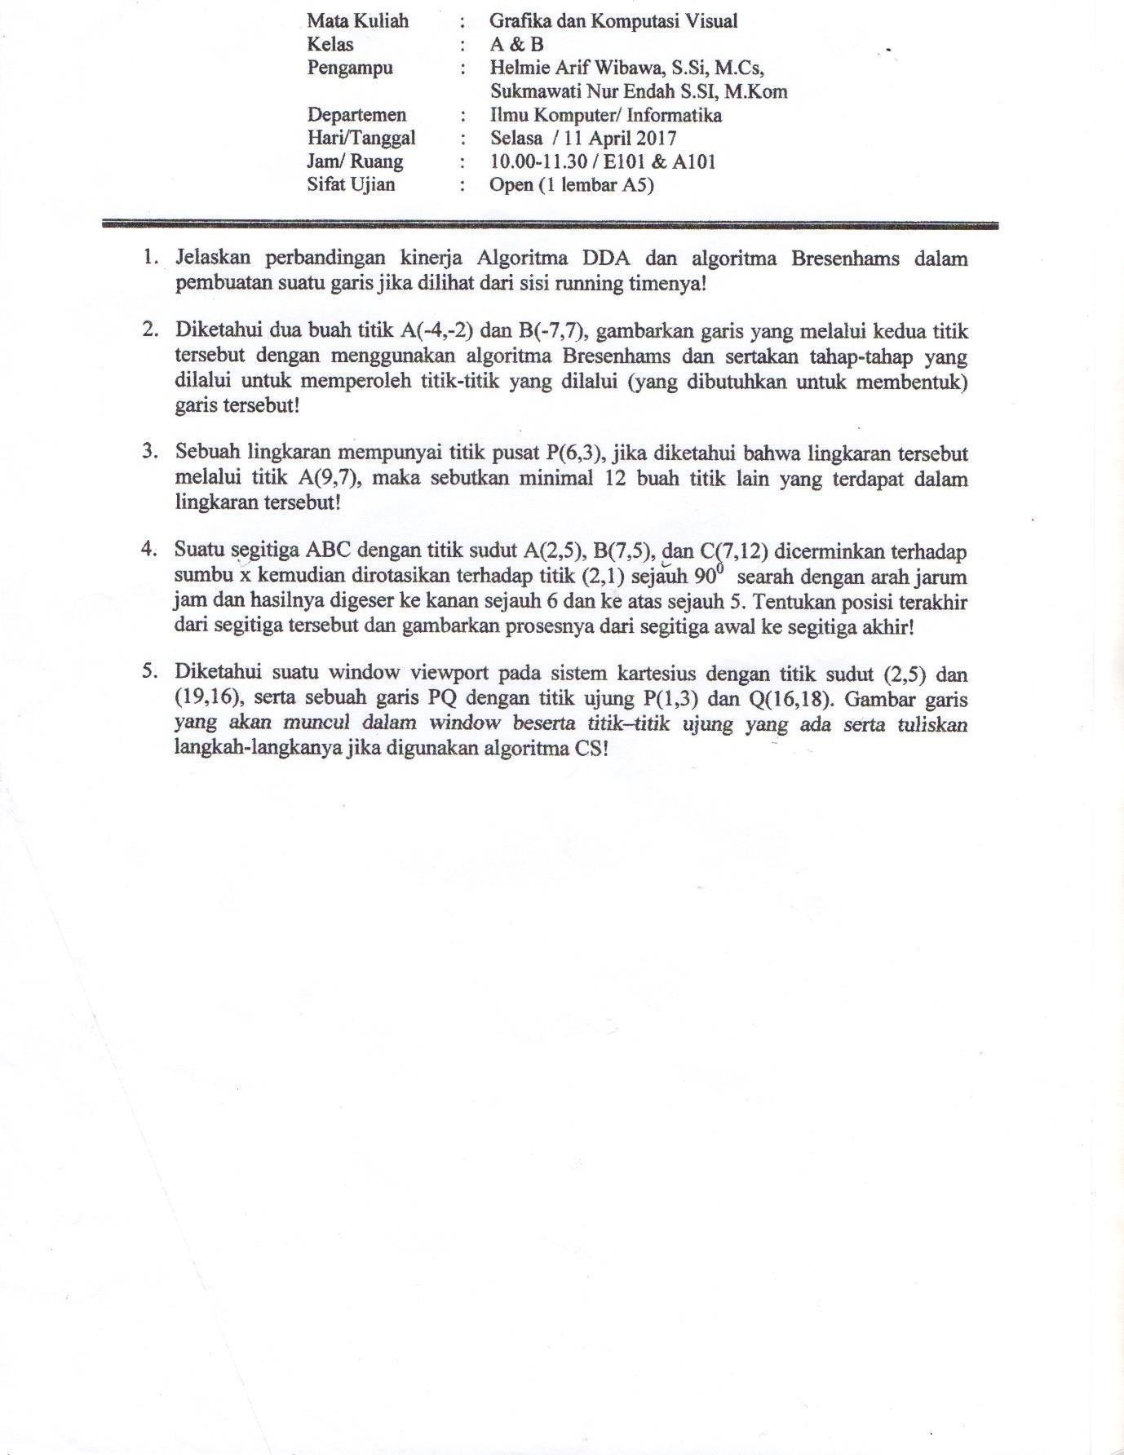

**UJIAN AKHIR SEMESTER 2016/2017**

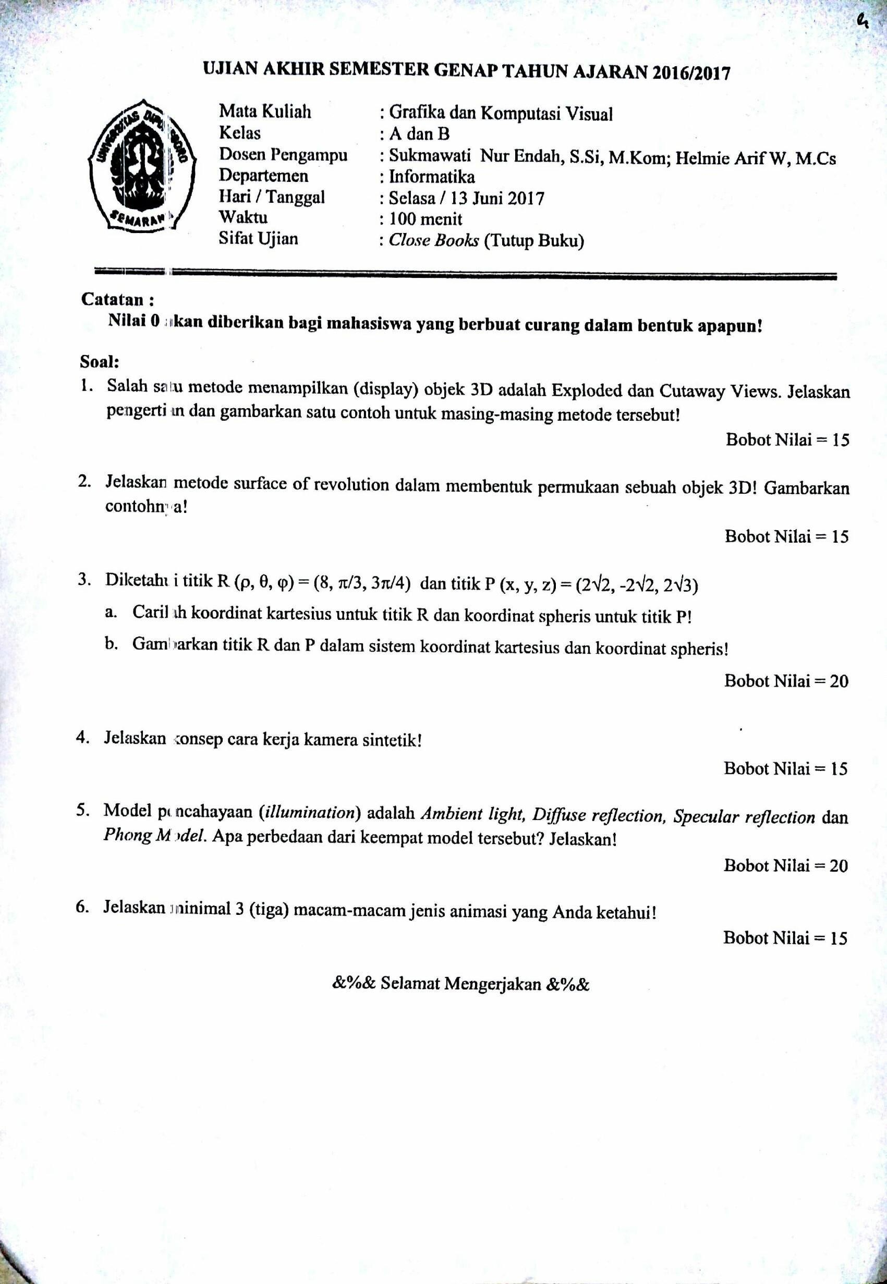

**UJIAN TENGAH SEMESTER 2017/2018**

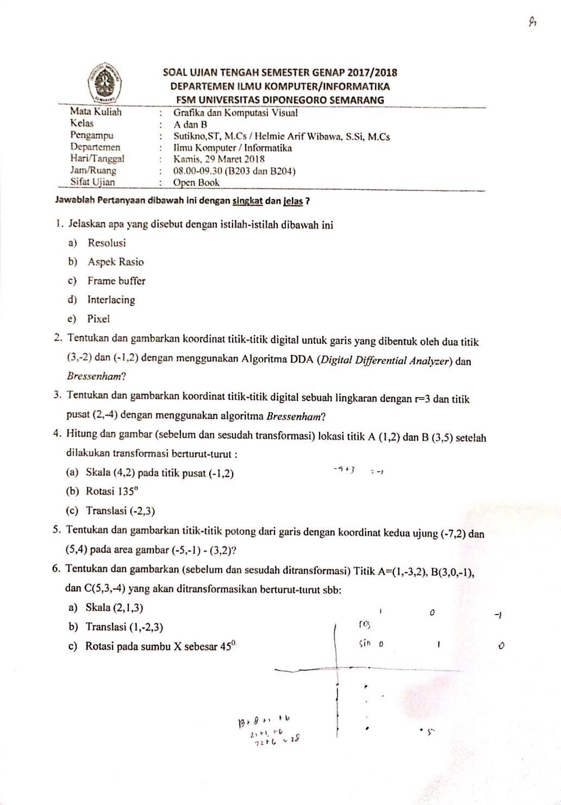

**UJIAN AKHIR SEMESTER 2017/2018**

